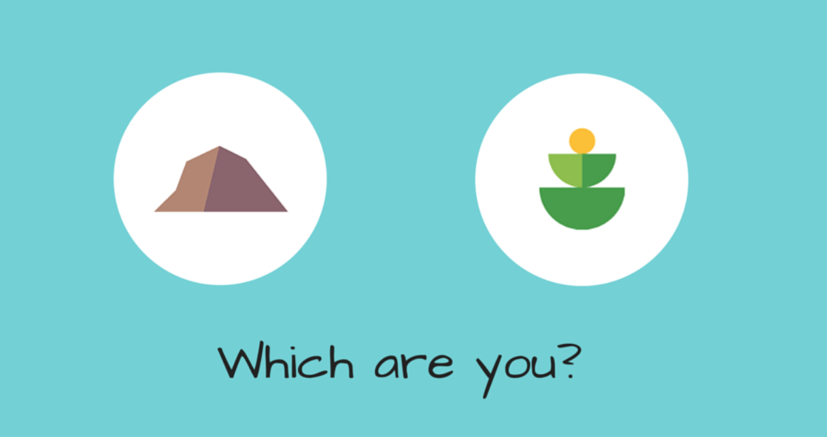

MINDSET OF GROWTH

I honestly live in an exciting world in my head. I love my friends, my partner is literally the bomb…yes he is!….my cat is actually a puppy and my kids are funny, capable and strong. I was raised with love, allowing growth, confidence and the ability to develop at my own pace…never feeling like I was an under achiever. My parents STILL inspire to me a better person…give, learn and be kind.

I LOVEEEEE getting older, as it comes with life experience and wisdom. I still can hear my 18 year old voice in my head but its gentler now….not so full of itself….. I am kinder to myself and realise…finally …that I am not and cannot be perfect…..that sentence alone has allowed so much growth…….I AM NOT AND CANNOT BE PERFECT….therefore I AM.

This means that I accept I am not a supermodel…but I am healthy and take care of my skin, weight and glow.
I accept I am not an elite athlete but I am sort of fit and ready to go to enter things on a whim to participate in.
I accept that I have knowledge gaps in my field, but very happy to find out anything…and when I am honest about this, find that my peers feel the same way ……
I accept that I don’t do much housework as often as some, but I do get out and do much more fun stuff more often …let’s face it, I don’t want memories of mopping all the time.

I accept that non-perfect is better then perfect because there is NO pressure.. I don’t have high expectations of myself and others don’t of me….
This acceptance of non-perfect is so perfect as this amazing thing has happened………. I will continuously try new things …..as I don’t feel pressure to be ace at them! I mean, what’s the worst thing that can happen? I fail…oh well…..NEXT!! I don’t put all my eggs into one basket…so I just move the the next one. I never dwell….I am never bored.

Evidence shows that we are educated to think about intelligence, and that effort shapes our response to adversity as well as our ability to thrive. A fixed mindset is that of someone who believes they are capable of and the extent of their ability to achieve success. They tend to consider challenges as risky situations which may reveal their inadequacy and avoid trying something new in order to ward off potential failure……

A growth mindset though, provides the owner of a belief that effort trumps talent. A lack of talent is just the starting point, since it’s the process of learning and gradual growth which is attractive and gratifying…………..there’s literally no filter for “NO or WHAT IF?”. It’s a clear “WHY NOT....I’M IN!!!”

The view you adopt profoundly affects the way you lead your life. It can determine whether you become the person you want to be and whether you accomplish the things you value…

So much positive comes out of a growth mindset, but for me the most important, is the development of GRIT and RESILIENCE. This develops out of learning to handle failure, rejection and negativity. It’s substituted with an attitude of strength and determination.

A fixed mindset is likely to give up or back down when faced with a challenge…a growth mindset says…bring it on and laughs…..even with fear…that’s ok….that’s growing!!!

It’s only adding to a pile of ability to handle situations and strength. In the end I think it’s fun..growing means trying new things…and I might find one I’m great at!! (….still trying lol) It also means meeting new people and learning to listen….

There is heaps to learn out there….we don’t know what we don’t know…. It can be learning a language, or an instrument, trying an adventure, taking up a sport, trying a new job, moving towns….grow grow grow!!! We don’t have to be perfect at it!!!

Learn to adopt a growth mindset and it will make you smile more, laugh harder, be more frightened and a darn lot more proud of yourself… I seriously want to get to the end of my life knowing a had a blast!! Fell a lot and got back up! Challenged and huge smile wrinkles all over my face…….

